Learner’s Spelling Dictionary

What is Learner’s Spelling Dictionary
# Source: AI Source: Provided by: [Data Path: Persons Table -> ID Column: 1, Name_En Column: Motasem Essam] -> From: [Chatgpt (GPT-4-turbo)] on [7/30/2025]
A Learner’s Spelling Dictionary is specifically designed for students, language learners, children, or anyone developing spelling skills. It focuses not only on correct spelling, but also on helping users understand, pronounce, and apply the words in context.

✅ Key Features:
# Source: AI Source: Provided by: [Data Path: Persons Table -> ID Column: 1, Name_En Column: Motasem Essam] -> From: [Chatgpt (GPT-4-turbo)] on [7/30/2025]
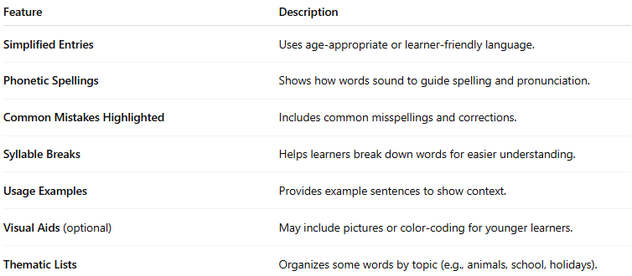
Feature | Description
Simplified Entries | Uses age-appropriate or learner-friendly language.
Phonetic Spellings | Shows how words sound to guide spelling and pronunciation.
Common Mistakes Highlighted | Includes common misspellings and corrections.
Syllable Breaks | Helps learners break down words for easier understanding.
Usage Examples | Provides example sentences to show context.
Visual Aids (optional) | May include pictures or color-coding for younger learners.
Thematic Lists | Organizes some words by topic (e.g., animals, school, holidays).

👤 Target Audience:
# Source: AI Source: Provided by: [Data Path: Persons Table -> ID Column: 1, Name_En Column: Motasem Essam] -> From: [Chatgpt (GPT-4-turbo)] on [7/30/2025]
- Children (ages 5–12)
- ESL/EFL learners (English as a Second/Foreign Language)
- Literacy programs
- Special education (including dyslexia support)

📘 Examples:
# Source: AI Source: Provided by: [Data Path: Persons Table -> ID Column: 1, Name_En Column: Motasem Essam] -> From: [Chatgpt (GPT-4-turbo)] on [7/30/2025]
- Oxford Children’s Spelling Dictionary
- Collins First Spelling Dictionary
- Macmillan First Dictionary
- Longman Young Learners’ Dictionary

🟢 Benefits:
# Source: AI Source: Provided by: [Data Path: Persons Table -> ID Column: 1, Name_En Column: Motasem Essam] -> From: [Chatgpt (GPT-4-turbo)] on [7/30/2025]
- Promotes independent learning
- Encourages spelling confidence
- Supports both reading and writing skills
- Accessible for different age or skill levels

🔴 Limitations:
# Source: AI Source: Provided by: [Data Path: Persons Table -> ID Column: 1, Name_En Column: Motasem Essam] -> From: [Chatgpt (GPT-4-turbo)] on [7/30/2025]
- Limited vocabulary compared to standard dictionaries
- Simplified definitions may lack depth for advanced learners

